|  |  |  |
| --- | --- | --- |
| Mathematics Department | |  |
| Course: A1MAA | |
| Topic Title: Skills Test 2 | |
| Student Name:_____________________________________ | Date: ____________ | | |
|  | Time Allowed: | | |
|  | Marks: / | | |



**Multiple Choice**

*Identify the choice that best completes the statement or answers the question.*

1 Which of the following is NOT a matrix?

A  B 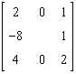 C  D  E 

2 What is the order of **A** if **A** = ?

|  |  |  |  |
| --- | --- | --- | --- |
| A | 10 | D | 1  10 |
| B |    | E |    |
| C | 10  1 |

3 How many elements would a 4 x 6 matrix contain?

|  |  |  |  |
| --- | --- | --- | --- |
| A | 10 | D | 31 |
| B | 28 | E | 24 |
| C | 9 |

4 Which of the following is a row matrix?

A  B  C  D 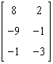 E 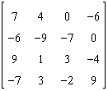

5 Which of the following is a column matrix?

A  B  C 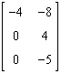 D  E 

6 Which of the following is a square matrix?

A  B 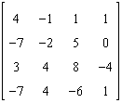 C  D  E 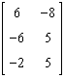

7 Which of the following is a zero matrix?

A 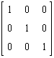 B  C  D  E 

8 What kind of matrix is: ? A zero B row C identity D column E square

9 Which of the following is an identity matrix?

A  B  C  D 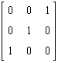 E 

10 If **A** = 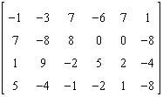, state the value of *a*31.

|  |  |  |  |
| --- | --- | --- | --- |
| A | 0 | D | –1 |
| B | 7 | E | 1 |
| C | 9 |

11 If **A** = 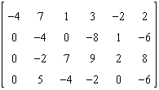, state the value of *a*42 + *a*31.

|  |  |  |  |
| --- | --- | --- | --- |
| A | –8 | D | 8 |
| B | 5 | E | –7 |
| C | 7 |

12 Kim, Wendy and Tran scored the following marks on four maths tests. Kim scored 9, 25, 11 and 17. Wendy scored 9, 20, 16 and 18. Tran scored 10, 23, 12 and 20. Which of the following matrices could be used to record their marks?

|  |  |  |  |
| --- | --- | --- | --- |
| A |  | D |  |
| B |  | E |  |
| C |  |

13 Calculate  + .

A  B  C 

D  E 

14 If A = , find 2A

A  B  C  D  E 

15 If **A** = 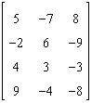 and **B** = 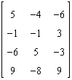, find **A – B**.

A 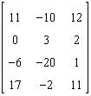 B 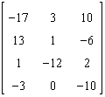 C 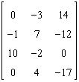

D 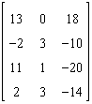 E 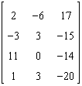

16 If **A** =  and **B** = 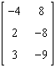, find 2**A +** 2**B**.

A 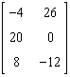 B 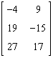 C 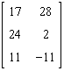 D 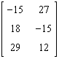 E 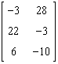

17 If matrices **A** and **B** are of order 3 x 2 and 2 x 2 respectively, then circle the true statement.

|  |  |
| --- | --- |
| A | The order of **AB** is 2 x 2 |
| B | The order of **AB** is 2 x 3 |
| C | The multiplication **AB** is undefined. |
| D | The order of **AB** is 3 x 2 |

18 The prices in the matrix below need to be marked up by 15%.



Which of the following is the matrix for the new prices?

A B C

  

D E

 